Ultra-rapid microwave synthesis of Li_{3-x-y}M_{x}N (M= Co, Ni and Cu) nitridometallates.
Nuria Tapia-Ruiz, ª Josefa Vidal Laveda, Ronald I. Smith,^{b} Serena A. Corrª and Duncan H. Gregoryª*

SUPPLEMENTARY INFORMATION

Table S1 Lattice parameters and cell volumes obtained from indexed powder X-ray data for samples (1-7).

Sample | M | x | a/ Å | c/ Å | V/ Å³
1 | Ni | 0.1 | 3.668(2) | 3.8416(5) | 44.77(2)
2 | Ni | 0.22 | 3.688(1) | 3.741(4) | 44.05(5)
3 | Ni | 0.29 | 3.697(6) | 3.72(2) | 44.08(2)
4 | Co | 0.09 | 3.667(3) | 3.8267(8) | 44.56(4)
5 | Co | 0.21 | 3.678(2) | 3.804(3) | 44.57(4)
6 | Co | 0.3 | 3.697(7) | 3.772(2) | 44.65(9)
7 | Cu | 0.11 | 3.670(3) | 3.806(7) | 44.32 (4)

Table S2 Thermal displacement parameters for atoms in samples 1-7.

Atoms | Uª x 100  /A² |  |  | 1 | 2 | 3 | 4 | 5 | 6 | 7
M/Li(1) |  | U_{i} / U_{e} | 2.64 |  | 1 | 0.14 | 1.58 | 3.90 | 2.49 | 1.33
(0,0,0.5) |  | U₁₁ | 3.8(9) |  | - | 0.2(1) | 2.1(3) | 4.6(7) | 3.9(4) | 2.5(3)
 |  | U₃₃ | 0.2(9) |  | - | 0.1(3) | 0.4(4) | 2.31(3) | 1.4(1) | 1.5(3)
N |  | U_{i} / U_{e} | 1.55 |  | 2.35 | 2.98 | 1.21 | 1.58 | 2.33 | 1.69
(0,0,0) |  | U₁₁ | 1.33(6) |  | 1.56(5) | 1.96(5) | 1.00(5) | 1.38(7) | 1.99(4) | 1.08(4)
 |  | U₃₃ | 1.9(1) |  | 3.9(1) | 4.97(2) | 1.60(7) | 2.0(1) | 2.98(7) | 2.9(8)
Li(2) |  | U_{i} / U_{e} | 3.59 |  | 4.28 | 3.82 | 2.37 | 2.31 | 3.12 | 4.79
(0.3333, 0.6667, 0) |  | U₁₁ | 1.6(3) |  | 2.7(3) | 2.0(2) | 1.5(2) | 1.5(3) | 2.3(2) | 1.6(2)
 |  | U₃₃ | 7.5(9) |  | 7.3(9) | 7.4(8) | 4.0(4) | 3.9(7) | 4.7(4) | 9.8(8)
ª U₁₁ = U₂₂ = 2 U₁₂ and U₁₃ = U₂₃ = 0.

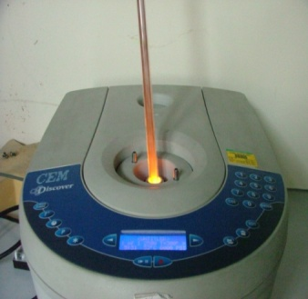
Fig. S1 Photograph showing a reaction in progress demonstrating the occurrence of an orange-yellow glow following Li evaporation.

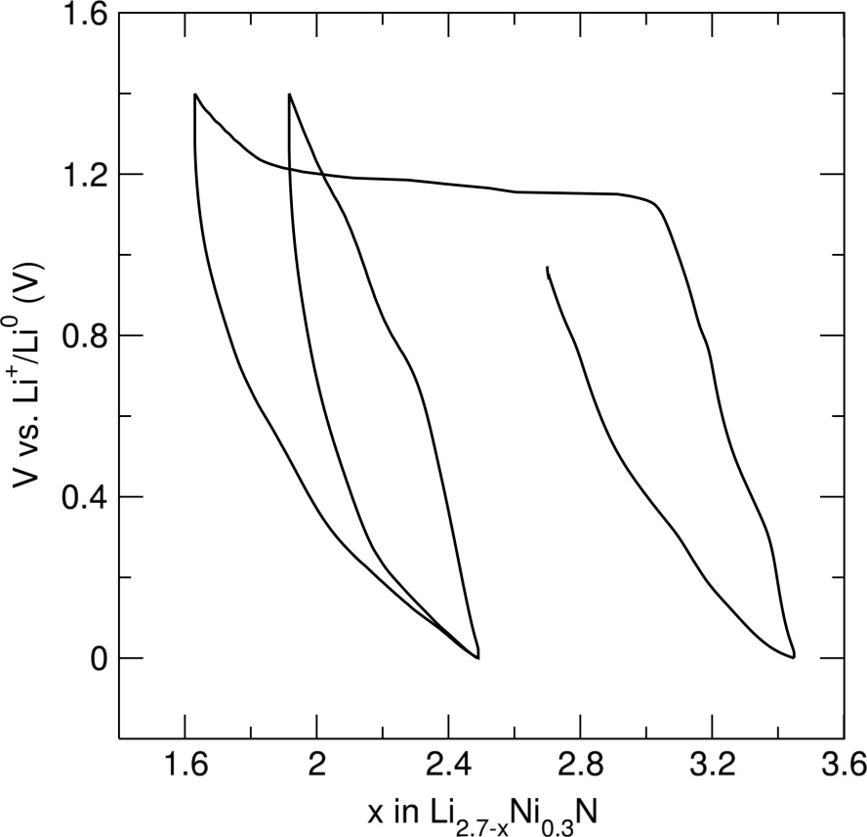
Fig. S2 First two charge/discharge cycles of Li_{2.7-x}Ni_{0.3}N (3) between 0 and 1.4 V at a C/30 rate.

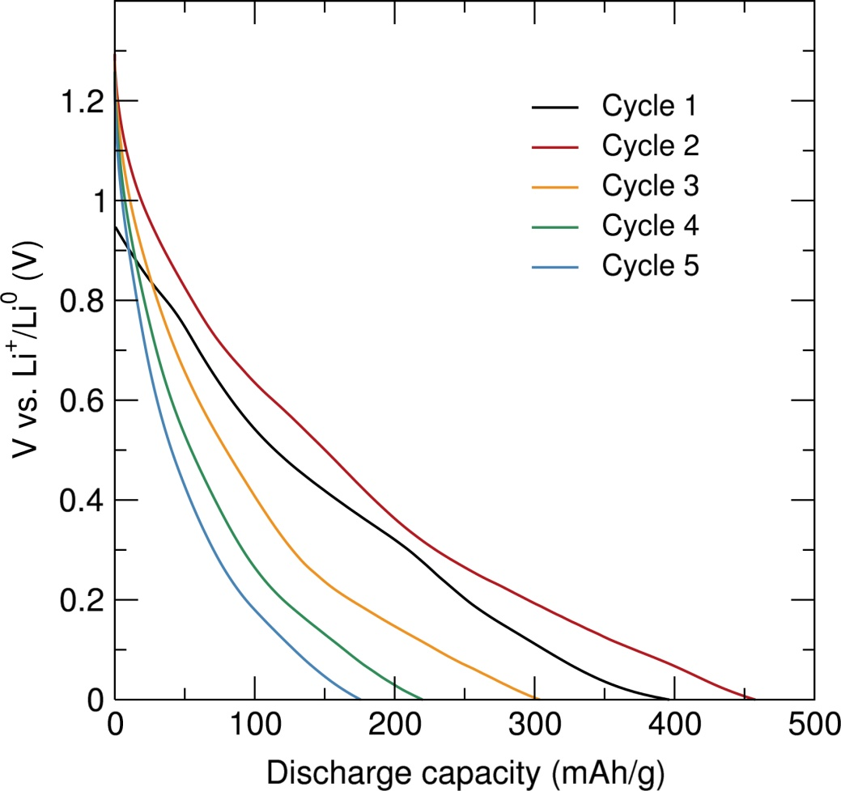
Fig. S3 Discharge capacity for the first five cycles of Li_{2.7-x}Ni_{0.3}N (3) tested galvanostatically against lithium metal between 0 and 1.4 V at a C/30 rate.

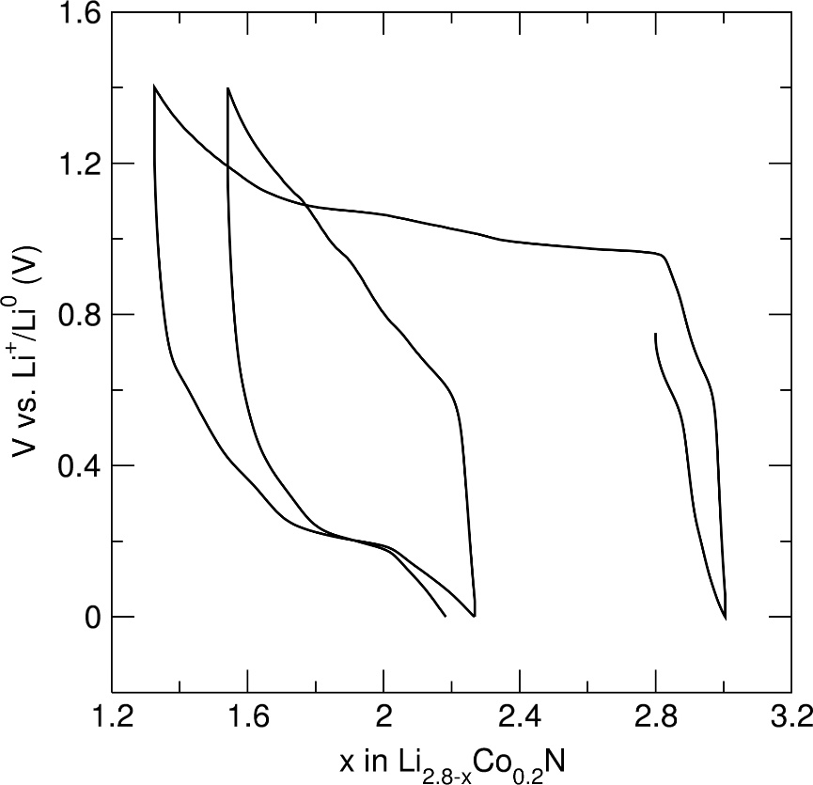
Fig. S4 First two charge/discharge cycles of Li_{2.8-x}Co_{0.2}N (5) between 0 and 1.4 V at a C/30 rate.

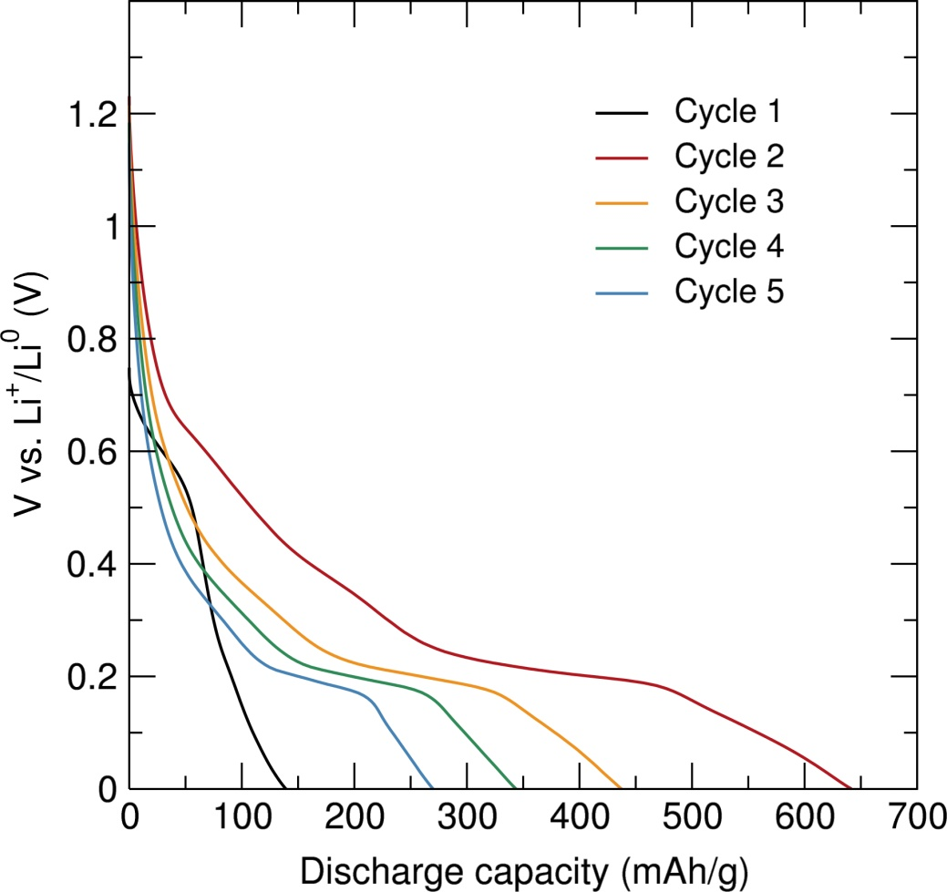
Fig. S5 Discharge capacity for the first five cycles of Li_{2.8-x}Co_{0.2}N (5) tested galvanostatically against lithium metal between 0 and 1.4 V at a C/30 rate.

